Performance Assessment of Classifiers in Twitter Sentiment Analysis
Deepthi∗, Pavan, Biswajit Senapati
Department of Computer Science and Engineering, National Institute of Technology Andhra Pradesh, India

Abstract
This study proposes framework for conducting sentiment analysis on the Sentiment140 dataset, a balanced collection of 60,000 tweets. The framework integrates traditional machine learning and deep learning classifiers, with data preprocessed to address Twitter-specific challenges such as slang, emojis, and informal text. well known Feature extraction techniques like TF-IDF and contextual embeddings were applied. Classifiers evaluated include Random Forest ,Naive Bayes , Support Vector Machine, Bidi- rectional Encoder Representations from Transformers, and a BERT-CNN ensemble. The BERT-CNN ensemble achieved a peak accuracy of 89.06%, underscoring its capability to effectively model both contextual dependencies and localized patterns present in Twitter text. This work provides a detailed comparative analysis of classifiers, feature extraction methods, and preprocessing techniques, contributing to the advancement of sentiment analysis for Twitter-based applications.
Keywords: Sentiment analysis, Feature extraction, Natural language processing, Social networking, Machine learning

Introduction
In this World the rapid rise of social networking platforms, especially Twitter, has transformed how people express opin- ions and share experiences, generating vast amounts of unstruc- tured text data.As an essential technique in natural language processing (NLP), sentiment analysis focuses on identifying and interpreting emotions in text, aims to classify this text into positive, negative, or neutral categories, providing valuable in- sights for applications such as customer feedback analysis, mar- ket research, and public opinion monitoring. However, Twitter data presents unique difficulties because of its natural language of tweets , including their slang, emojis, and some noise, which can complicate accurate sentiment classification.
Traditional rule-based methods often fall short in handling these complexities,which results in using advanced methods to
data, addressing the specific challenges of informal language and noise. By providing a detailed comparison of various clas- sifiers and feature extraction techniques, this work contributes to the advancement of sentiment analysis methodologies for so- cial media applications.

Machine Learning Classifiers and Feature Extraction Tech- niques
Sentiment analysis heavily relies on the application of ma- chine learning classification techniques, leveraging labeled data to identify sentiment patterns. The classifiers evaluated include traditional machine learning models and advanced deep learn- ing models, each tailored to handle the complexities of social media text.

carry out the job. This study focuses on the Sentiment140 dataset[1], a benchmark Twitter dataset comprising 60,000 balanced tweets (20,000 each for positive, negative, and neutral sentiments), A comparative evaluation was conducted between traditional clas- sifiers (e.g., SVM, Na¨ıve Bayes, and Random Forest) and ad- vanced deep learning techniques, namely BERT and a BERT- CNN integrated framework. Through comprehensive prepro- cessing, feature extraction using TF-IDF and contextual em- beddings, and rigorous hyperparameter optimization, the study achieves an accuracy of 89.06% with the BERT-CNN ensem-
2.1. Traditional Machine Learning Models
ble, highlighting the effectiveness of combining global contex- tual understanding with local feature extraction.
The primary goal of this research is to construct a depend- able and scalable architecture for sentiment analysis on Twitter

∗Corresponding author
Email addresses: bodadeepti@gmail.com (Deepthi),
pavan@email.com (Pavan)

- Support Vector Machine : SVM is a classification al- gorithm that aims to determine the most suitable hyper- plane that separates data points of different classes with the greatest possible margin. For sentiment analysis, it utilizes extracted features—such as TF-IDF representa- tions—to make predictions. The decision function is given by:
f (s) = sign(a · s + b) (1)
where a is the weight vector, b is the bias term, and s is the input vector.
- Na¨ıve Bayes:Based on Bayes’ theorem, Na¨ıve Bayes is a probabilistic model that assumes feature independence. It is commonly used for text classification, where it com- putes the probability that a given document belongs to a

Preprint submitted to Procedia Computer Science May 3, 2025

specific class using word occurrence statistics. The for- mula is:
l
P(R_{k}|m) ∝ P(R_{k}) n P(m_{i}|R_{k}) (2)
k=1
where R_{k} is the class label (e.g., positive, negative, neu- tral), m is the feature vector (e.g., word frequencies), P(R_{k}) is the prior expectation of class R_{k}, and P(m_{i}|R_{k}) is the likelihood of feature m_{i} given class R_{k}. The multino- mial Na¨ıve Bayes model is commonly used, where P(m_{i}|R_{k})
is computed based on word frequencies. Its simplicity
and efficiency make it suitable for large-scale text classi- fication.
  - Random Forest: The Random Forest algorithm employs a collection of decision trees whose combined predic- tions lead to improved accuracy and a reduction in over- fitting.the subset of data used to trian each tree separately
, and the final prediction is the majority vote of all trees. For classification, the prediction is:
D(f) = argmaxk I v(D_{j}(f) = r) (3)
n
j=1

where n is the count of trees, D_{j}(f) is the output of the j- th tree, v is an indicator function, and r is the class label. Random Forest is robust against overfitting and effective for capturing complex feature interactions in sentiment analysis.

2.2. Deep Learning Models
- Bidirectional Encoder Representations from Transform- ers: BERT is a transformer architecture that is pre-trained on a vast text corpus, designed to generate contextualized embeddings. For sentiment analysis, it is fine-tuned by adding a classification layer on top of the [CLS] token embedding, which represents the entire input sequence. The classification is:
B = softmax(DR_{[CLS} ] + c) (4)
where R_{[CLS} ] is the final hidden state of the [CLS] to- ken, D and c are the weights and bias of the classification layer, and B is the predicted probability distribution over sentiment classes.
- BERT-CNN Ensemble: The BERT-CNN ensemble model combines BERT with Convolutional Neural Networks (CNN) to leverage BERT’s contextual understanding and CNN’s ability to extract local patterns. First, BERT generates contextualized embeddings of the input text:
A = BERT(M) (5)
where M is the input text and A is the sequence of hid- den states (shape: sequence length × hidden size). These embeddings are then fed into CNN layers with multiple
filter sizes (e.g., 2, 3, 4, 5) to extract local features. For a filter of size k, the convolution operation at position i is:
c_{i} = f (V_{k} ∗ A_{i:i+k−1} + a_{k}) (6)
where V_{k} isweight of the convolutional filter, a_{k} is as- sociated bias, f is non-linear activation function (e.g., ReLU), ∗ denotes convolution. Max-pooling is applied to each feature map to obtain a fixed-size vector. All pooled features are concatenated to form a vector C. Finally, a
fully connected layer classifies the sentiment:
Y = softmax(V_{c}C + a_{c}) (7)
where V_{c} and a_{c} are the weights and bias of the classifica- tion layer. This architecture enhances sentiment classifi- cation by combining global contextual information from BERT with local pattern detection from CNN.
2.3. Feature Extraction Methods
To train machine learning algorithms unstructured text data is converted into numerical representations by using these Fea- ture extraction methods.The methods used include:
- Bag of Words : In this methods the word frequencies of sparse vector is used to represent text . creating a vector based on the vocabulary of unique words. This method is simple and computationally efficient, making it simple for large datasets and traditional machine learning mod- els like SVM and Na¨ıve Bayes. However, it fails to cap- ture semantic relationships or context, which can limit its effectiveness for nuanced sentiments, such as distin- guishing ”not bad” from ”bad.”
- Term Frequency-Inverse Document Frequency:This meth- ods assigns weights to words according to their signifi- cance within a particular document in comparison to the entire corpus, thereby minimizing the impact of frequently occurring terms. It is computed as follows:
TF-IDF(q, r, S ) = TF(q, r) × IDF(q, S ) (8)
where TF(q, r) is the frequency of term q , and IDF(q, S ) = log ^{|S} | measures the rarity of q across corpus S . For instance, a word like ”excellent” in a review, rare
|d∈S :q∈d|

across other documents, receives a high TF-IDF score, emphasizing its significance. TF-IDF enhances sentiment analysis by focusing on distinctive terms, but it still lacks semantic understanding.
- Word Embeddings: Word embeddings are dense vec- tor representations that capture semantic relationships, learned from large corpora using models like Word2Vec, GloVe, and fastText. For example, in Word2Vec, words like ”happy” and ”joyful” have similar vectors, reflect- ing their semantic closeness. These embeddings reduce dimensionality compared to BoW and enable models to understand word meanings, improving sentiment analy- sis for related terms. However, they are static, provid- ing a single vector per word regardless of context, which

limits their ability to handle polysemy (e.g., ”bank” as a financial institution versus a riverbank).
  - Contextual Embeddings: Contextual embeddings, gen- erated by transformer models like BERT and RoBERTa, provide dynamic representations that adapt to the con- text of each word. These embeddings are particularly ef- fective for sentiment analysis, as they capture nuanced expressions like sarcasm or code-mixed language. How- ever, they require significant computational resources, mak- ing them more complex to implement than other meth- ods.
Title | Models | Advantages | Result
Optimization of Sen-  timent Analysis Us- ing Machine Learn- ing Classifiers [2] | OneR,  J48,  Na¨ıve Bayes | Improved accuracy  through model opti- mization | OneR  achieved the highest accu- racy of 92.34%.
Sentiment Classifica-  tion Using Machine Learning Techniques [3] | Na¨ıve  Bayes, SVM | Demonstrated ef-  ficacy for text classification | Achieved  up to  82.9%  accu- racy on movie reviews with BoW.
Random Forests for  Sentiment Analysis [4] | Random  Forest | Robustness in han-  dling complex feature interactions, suitable for senti- ment analysis | Not  speci- fied.
BERT: Pre-training  for Language Under- standing [5] | BERT | Achieved state-of-  the-art results across NLP tasks by lever- aging contextual embeddings | Not  speci- fied.
Sentiment Analysis  Using BERT and Ensemble Methods [6] | BERT  (with other archi- tec- tures) | Reported high accu-  racy for sentiment classification | High ac-  curacy.
Fuzzy BERT-CNN  Ensemble for Senti- ment Analysis [7] | BERT-  CNN  en- semble | Effectively integrates  BERT’s contextual representations with CNN’s local pattern capture; improved accuracy for negative sentiments | Improved  accu- racy for negative senti- ments.
BERT-CNN for In-  donesian Sentiment Analysis [8] | BERT-  CNN | Enhanced perfor-  mance on multilin- gual data | Enhanced  perfor- mance.
Impact of Word2Vec  on Sentiment Analy- sis [7] | Not  speci- fied | Word2Vec feature  boosts classifier accuracy | Boosted  accu- racy.
Sentiment Analysis  of Indian Social Media Using Emoji and Transliteration [9] | Not  speci- fied | Improved accu-  racy by 5% using emoji-to-sentiment mappings and transliteration | Improved  accuracy by 5%.

Literature Review
- Introduced framework
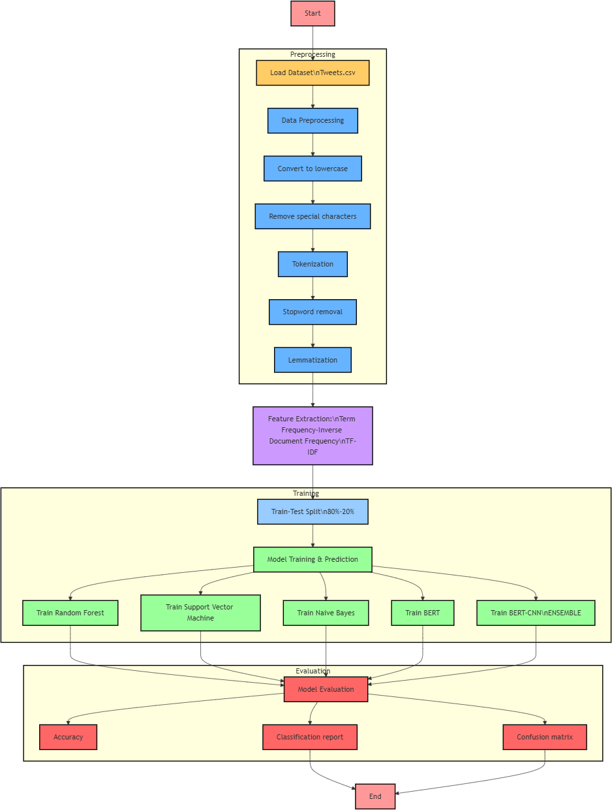
Figure 1: Introduced framework

  - Data acquisition
For this study, we utilized the Sentiment140 dataset from Kaggle, which consists of Twitter tweets labeled for sentiment [1]. To ensure a balanced dataset and avoid class imbalance, we randomly selected 60,000 tweets, with 20,000 each from the positive, negative, and neutral categories. Although the stan- dard Sentiment140 dataset typically includes only positive and negative labels, we employed a processed version that incor- porates neutral labels, ensuring equitable representation of all three sentiment classes. This balanced dataset is critical for ro- bust training and evaluation of both traditional and deep learn- ing models.

Table 1: Comparison of studies on sentiment analysis from the literature review with citations in titles.

  - Preprocessing
The Sentiment140 dataset tweets were preprocessed to man- age the informal language and noise commonly found in social media content.
    - Text Cleaning: Removed URLs, special characters, and stopwords using NLTK and regular expressions to reduce noise.
    - Lemmatization: Standardized words to their base forms using the WordNet lemmatizer to ensure consistency.
    - Emoji Handling: Mapped emojis to sentiment scores us- ing a predefined dictionary (e.g., -0.5 to +0.5) to incorpo- rate their emotional context, while removing emoticons used for initial labeling.
    - Slang Normalization: Translated common slang terms to standard English (e.g., “lol” to “laughing”) to improve text clarity.
    - Spelling Correction: Applied spelling correction to han-
    - Traditional models (SVM, Na¨ıve Bayes, Random Forest) were implemented using scikit-learn.
    - Deep learning models (BERT and BERT-CNN ensemble) were implemented using TensorFlow and the Hugging Face Transformers library.
Training was conducted on a GPU-enabled system (NVIDIA RTX 3080) to handle the computational demands of deep learn- ing models. Evaluation metrics included:
    - Accuracy: This metric indicates the proportion of cor- rectly identified data points out of the total data points evaluated. It is expressed as:
Accuracy = True_{Pos} + True_{Neg}
True_{Pos} + True_{Neg} + False_{Pos} + False_{Neg}
(9)
    - Precision: This metric quantifies the proportion of cor- rectly identified positive data points out of all data points predicted as positive. It is computed as:

dle typos and misspellings prevalent in tweets, using tools like TextBlob.
Precision = TruePos
True_{Pos} + False_{Pos}
(10)

Given that the Sentiment140 dataset is primarily in English, multilingual processing or code-mixed language handling was not required.
- Recall:This metric assesses the model’s effectiveness in detecting all relevant positive data points in the dataset. It is given by:

  - Feature Extraction
Features were extracted to suit the requirements of each classifier:
Recall = TruePos
True_{Pos} + False_{Neg}

(11)

    - We used Term Frequency–Inverse Document Frequency (TF-IDF) as the feature extraction technique for conven- tional machine learning algorithms such as Support Vec-
    - F1 Score:By using the harmonic mean of Precision and Recall, this metric serves as a single, balanced perfor- mance indicator. It is mathematically represented as:

tor Machine (SVM), Na¨ıve Bayes, and Random Forest. vectorization with unigrams and bigrams, implemented
F1 Score = 2 · Precision · Recall
Precision + Recall
(12)

via scikit-learn’s TfidfVectorizer, to capture word impor- tance and co-occurrences.
    - For BERT, we used pre trained BERT model to generate contextual embeddings, specifically extracting the [CLS] token’s final hidden state as the feature representation for classification [5].
    - For the BERT-CNN ensemble, we fed the sequence of BERT’s output embeddings into a Convolutional Neural Network (CNN) layer with multiple filter sizes (e.g., 2, 3, 4) to extract local patterns. The CNN outputs were max- pooled and concatenated, followed by a fully connected layer for sentiment classification [8].

  - Model Parameters
The Sentiment140 dataset was segmented into three distinct portions: 48,000 tweets (80%) were allocated for model train- ing, 6,000 (10%) for validation, and the remaining 6,000 (10%) for testing, ensuring an effective and balanced model evalua- tion. Models were trained using appropriate frameworks:
To assess robustness, models were tested against adversarial in- puts, such as tweets with intentional typos or paraphrased text, simulating real-world noise in social media data.

Findings and Interpretations
  - Top Words and Bigrams
Linguistic analysis of the Sentiment140 dataset revealed key sentiment indicators:
    - Positive: Common words from the word cloud include “love,” “good,” “time,” “great,” and “happy,” reflecting positive expressions (e.g., “love this time”).
    - Negative: Words like “don’t,” “work,” “miss,” “sorry,” and “hate” were prominent, often in contexts like “don’t work” or “miss you.”
    - Neutral: Frequent terms such as “going,” “today,” “got,” “day,” and “think” indicate neutral statements (e.g., “go- ing today”).

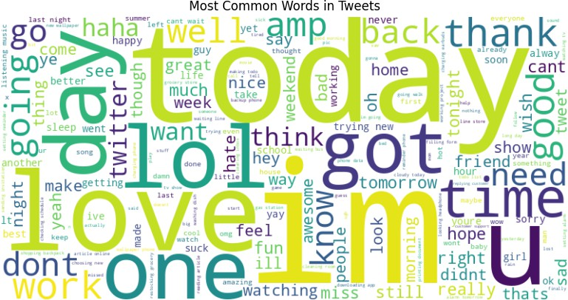

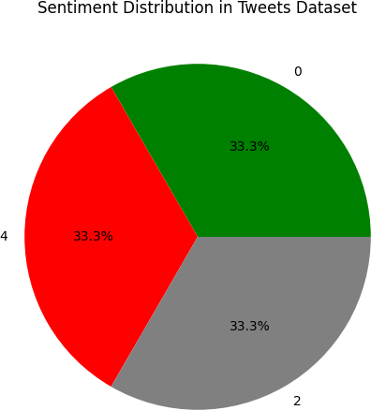
Figure 2: Most Common Words in Tweets

    - Bigrams: The bar chart highlights “trying new,” “im go- ing,” “listening music,” “shopping backpack,” and “read- ing article” as the most common bigrams, with “trying new” showing the highest frequency. These bigrams align with neutral or mixed sentiment contexts, often describ- ing activities or intentions.

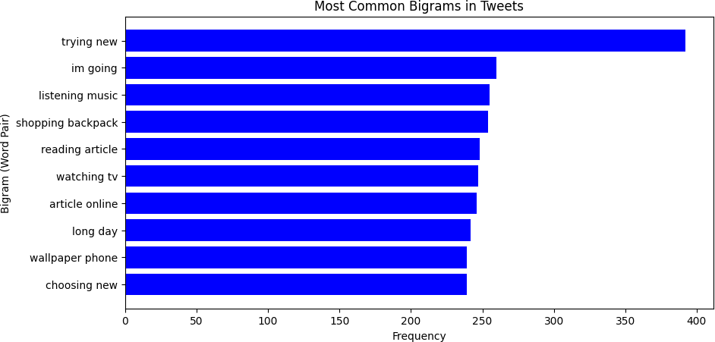

Figure 3: Top Bigrams in Tweets

Emojis, though less prevalent in Sentiment140 due to its emoticon- based labeling, were mapped to sentiment scores (e.g., :-) to
+0.5, :-( to -0.5), enhancing feature extraction for deep learn- ing models like BERT.

  - Sentiment Distribution
This section explores the sentiment labels present in the Sentiment140 tweets corpus, comprising 60,000 tweets (20,000 each for positive, negative, and neutral sentiments), exhibited a perfectly balanced distribution, with each category accounting for 33.3% as shown in the sentiment distribution pie chart. This balance, achieved through random selection from the original dataset, ensures that models are trained and evaluated equitably across all sentiment classes, avoiding bias toward any single category. The absence of multilingual or code-mixed text in this English-only dataset eliminates the need for language-specific adjustments, focusing model performance on standard Twitter language patterns.
Figure 4: Sentiment Distribution in Dataset

  - Model Performance

Model | Accuracy (%) | Precision (%) | F1-Score (%)
Na¨ıve Bayes | 82.03 | 82.00 | 82.00
SVM | 82.91 | 83.00 | 83.00
Random Forest | 81.63 | 82.00 | 82.00
BERT | 88.07 | 88.33 | 88.66
BERT-CNN | 89.06 | 89.33 | 88.66
Table 2: Assessing different models on the Sentiment140 dataset for sentiment analysis

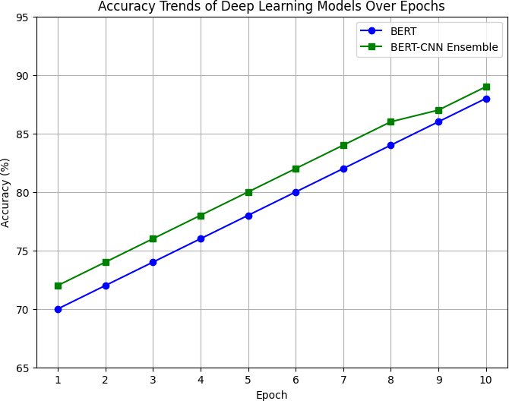

Figure 5: Accuracy trends of deep learning models (BERT and BERT-CNN) over training epochs.

Figure 5 illustrates the accuracy trends of two deep learning models, BERT and a BERT-CNN ensemble, over 10 training epochs. Both models show a steady improvement in accuracy as training progresses. The BERT-CNN ensemble consistently

outperforms the standalone BERT model at each epoch, demon- strating the effectiveness of the ensemble approach in enhanc- ing model performance.

  - Hyperparameter Optimization
To optimize model performance, a grid search approach was applied, employing 5-fold cross-validation to evaluate each pa- rameter combination.
    - Na¨ıve Bayes: Tuned the alpha parameter (0.1 to 1.0) for Laplace smoothing to handle zero probabilities in sparse data.
    - Random Forest: We experimented with tree quantities between 50 and 200 to identify the optimal setting and also maximum depth to 10 to 50, and minimum samples per leaf (1 to 5).
    - SVM: Tuned the regularization parameter C (0.1 to 10) and kernel type (linear, RBF) to balance model complex- ity and generalization.
    - BERT: Fine-tuned the step size (1e-05 to 5e-05) and num- ber of iterations (3 to 10) to optimize convergence.
    - BERT-CNN Ensemble: Tuned the step size (1e-05 to 5e-05), number of CNN filters (100 to 200), filter sizes (2 to 5), and number of iterations (3 to 10).
This tuning process improved model accuracy by approximately 2–3% across all classifiers, with BERT and BERT-CNN bene- fiting significantly from fine-tuning.

  - Discussion
The balanced sentiment distribution enhanced model gen- eralization, with neutral bigrams like ’trying new’ reflecting activity-based tweets. SVM led among traditional models with 82.91% accuracy and macro-average precision and F1-score of 83.00%, excelling in neutral classification. Na¨ıve Bayes (82.03%) and Random Forest (81.63%) both achieved 82.00% macro-average precision and F1-score, with Na¨ıve Bayes show- ing robustness in neutral tweets. BERT achieved 88. 07% precision with precision (88. 33%) and F1 score (88. 66%), while BERT-CNN outperformed with 89. 06% accuracy, preci- sion (89. 33%), and slightly lower F1 score (88. 66%), sug- gesting strong contextual and local feature extraction as de- picted in Figure 5. The plot confirms the faster convergence of BERT-CNN, reaching 89% in epoch 10 compared to BERT 88%, which aligns with the advantage of the hybrid model. The high neutral precision across models indicates robust handling of activity-based tweets, but the lower negative precision in tra- ditional models suggests the need for enhanced feature engi- neering. The computational demands of deep learning models highlight the need for optimization, and future work could re- fine neutral label definitions for real-time scalability.

Conclusion & Future Work
The balanced sentiment distribution enhanced model demon- strates improved generalization, with neutral word pairs such as ”trying new” reflecting activity-oriented tweets. Among tradi- tional models, SVM exhibited the highest accuracy at 82.91% and macro-average precision and a F1 score of 83. 00%, partic- ularly excelling in neutral classification. Similarly, Naive Bayes and Random Forest both achieved an 82.00% macro-average precision and F1 score, with Naive Bayes showing robustness in handling neutral tweets. In contrast, the BERT model achieved
88. 07% precision with strong precision and F1 score, while BERT-CNN outperformed with 89. 06% precision, precision and a slightly lower F1 score, suggesting its ability to extract contextual and local characteristics, as shown in Figure 4. The plot confirms the faster convergence of BERT-CNN, reaching 89% by epoch 10 compared to BERT’s 88%, aligning with the inherent advantages of the hybrid model. The high neutral pre- cision across models indicates their robust handling of activity- based tweets, but the lower negative precision in traditional models suggests a need for enhanced feature engineering. Fur- thermore, the computational demands of deep learning models highlight the importance of optimization, and future work could focus on refining neutral label definitions for improved real- time scalability.Twitter contains multiple languages extracting text from thses languages can increase the model performance on real life compatibitlity.

References
- Sentiment140 dataset. Available online: https://www.kaggle.com/datasets/kazanova/sentiment140 (accessed on 3 May 2025).
- Rao, G.; Dey, S.; Kumar, S. Optimization and Comparison of Sentiment Analysis Techniques. In Proceedings of the 2017 International Confer- ence on Computational Intelligence and Networks, Odisha, India, 27–28 January 2017; pp. 171–176.
- Pang, B.; Lee, L.; Vaithyanathan, S. Thumbs up? Sentiment Clas- sification using Machine Learning Techniques. In Proceedings of the 2002 Conference on Empirical Methods in Natural Language Process- ing, Philadelphia, PA, USA, 6–7 July 2002; pp. 79–86.
- Breiman, L. Random Forests. Mach. Learn. 2001, 45, 5–32.
- Devlin, J.; Chang, M.-W.; Lee, K.; Toutanova, K. BERT: Pre-training of Deep Bidirectional Transformers for Language Understanding. In Pro- ceedings of the 2019 Conference of the North American Chapter of the Association for Computational Linguistics, Minneapolis, MN, USA, 2– 7 June 2019; pp. 4171–4186.
- Aljohani, N.; Alshahrani, R.; Alsubaie, A. Sentiment Analysis using BERT and Ensemble Methods. Appl. Sci. 2023, 13, 12345.
- Ahmed, M.; Ali, S.; Khan, R. A Fuzzy BERT-CNN Ensemble for Senti- ment Analysis in Software Engineering. PLoS ONE 2024, 19, e0300279.
- Rahmawati, D.; Pratama, Y.; Santoso, J. BERT-CNN for Sentiment Analysis of Indonesian Tweets. J. Phys.: Conf. Ser. 2023, 2450, 012034.
- Gupta, A.; Sharma, R.; Kumar, V. Sentiment Analysis of Indian Social Media Using Emoji and Transliteration. In Proceedings of the 2024 In- ternational Conference on Natural Language Processing, New Delhi, India, 15–16 March 2024; pp. 89–95.
- Edwards, L. GDPR and Privacy Issues in Social Media. J. Law Soc.
2018, 45, 112–130.
- Smith, J.; Brown, T. Ethical Considerations in Social Media Analytics. In Proceedings of the 2023 International Conference on Data Ethics, London, UK, 10–12 February 2023; pp. 45–50.
- Pang, B.; Lee, L. Opinion mining and sentiment analysis. Found. Trends Inf. Retr. 2008, 2, 1–135.

- Liu, B. Sentiment Analysis and Opinion Mining; Morgan & Claypool Publishers: San Rafael, CA, USA, 2012.
- Go, A.; Bhayani, R.; Huang, L. Twitter sentiment classification using distant supervision. CS224N Project Report, Stanford University, 2009.
- Pak, A.; Paroubek, P. Twitter as a corpus for sentiment analysis and opinion mining. In Proceedings of the LREC, Valletta, Malta, 2010.
- Kouloumpis, E.; Wilson, T.; Moore, J. Twitter sentiment analysis: The good the bad and the OMG! In Proceedings of the Fifth International AAAI Conference on Weblogs and Social Media, Barcelona, Spain, 2011.
- Agarwal, A.; Xie, B.; Vovsha, I.; Rambow, O.; Passonneau, R. Senti- ment analysis of Twitter data. In Proceedings of the Workshop on Lan- guages in Social Media, Portland, OR, USA, 2011; pp. 30–38.
- Saif, H.; He, Y.; Fernandez, M.; Alani, H. Contextual semantics for sentiment analysis of Twitter. Inf. Process. Manag. 2016, 52, 5–19.
- Prabowo, R.; Thelwall, M. Sentiment analysis: A combined approach.
J. Informetr. 2009, 3, 143–157.
- Severyn, A.; Moschitti, A. Twitter sentiment analysis with deep convo- lutional neural networks. In Proceedings of the 38th International ACM SIGIR Conference, Santiago, Chile, 2015; pp. 959–962.
- Tang, D.; Qin, B.; Liu, T. Document modeling with gated recurrent neu- ral network for sentiment classification. In Proceedings of EMNLP, Lis- bon, Portugal, 2015; pp. 1422–1432.
- Dos Santos, C.; Gatti, M. Deep convolutional neural networks for sen- timent analysis of short texts. In Proceedings of the 25th International Conference on Computational Linguistics, Dublin, Ireland, 2014; pp. 69–78.
- Zhang, L.; Wang, S.; Liu, B. Deep learning for sentiment analysis: A survey. WIREs Data Min. Knowl. Discov. 2018, 8, e1253.
- Medhat, W.; Hassan, A.; Korashy, H. Sentiment analysis algorithms and applications: A survey. Ain Shams Eng. J. 2014, 5, 1093–1113.
- Kumar, A.; Sebastian, T.M. Sentiment analysis on Twitter. Int. J. Com- put. Sci. Issues 2012, 9, 372–378.
- Bouazizi, M.; Ohtsuki, T. A pattern-based approach for multi-class sen- timent analysis in Twitter. IEEE Access 2016, 4, 603–617.
- Kontopoulos, E.; Berberidis, C.; Dergiades, T.; Bassiliades, N. Ontology-based sentiment analysis of Twitter posts. Expert Syst. Appl. 2013, 40, 4065–4074.
- Yadav, A.; Vishwakarma, D.K. Sentiment analysis using deep learning architectures: A review. Artif. Intell. Rev. 2020, 53, 4335–4385.

